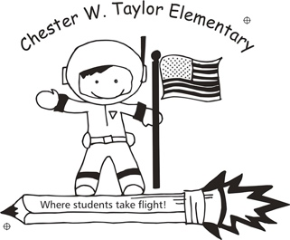

**Success Plan at a Glance 2024-2025**

|  |  |  |
| --- | --- | --- |
| Machine generated alternative text: Goal | **High Impact Instruction**  Teachers intentionally plan and deliver lessons that are aligned to the rigor of the standards that reflect the instructional shifts needed to integrate best practices into all content areas.   * Professional learning communities will continue to collaboratively plan, deliver and reflect on instruction aligned to the rigor of the standards  |  | | --- | | * + Teachers and staff will continue to deepen their knowledge of the New Florida BEST Standards in Math and ELA. |  * Teachers will use the ELN to plan for instruction in all content areas around the core actions. |
| Machine generated alternative text: Goal | **Data Driven Decisions**  CWTES will use a system to analyze data to monitor growth and teams will engage in problem-solving processes to monitor effectiveness of core instruction and intervention supports.   * Teachers and staff will continue to build a strong system that supports all academic needs. * Teachers and staff will continue to build a strong system that supports all student’s behavioral needs |
| Machine generated alternative text: Goal | **Collaborative Culture**  School teams will develop and sustain a culture of **collective responsibility** evident throughthe SuP,mission, vision, core values, goals, and intentional PD.   * CWTES will continue to work on our culture of collective responsibility * CWTES will continue to work on creating a compassionate school that builds student HOPE * CWTES will work to build staff morale back to where it was pre-covid |